Chapter 11: Feeding The World

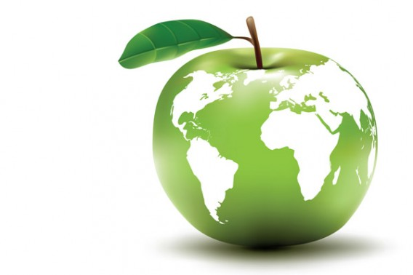

Can you….

1. Describe basic human nutrition requirements and complications by not meeting them?
2. Describe the advantages and disadvantages of industrial agriculture?
3. Explain the new management techniques in the Green Revolution and identify the advantages and disadvantages of each technique?
4. Describe how pesticide use effects species over time?
5. Identify genetic engineering and describe both benefits and concerns?
6. Explain what organic agriculture is along with the advantages and disadvantages?
7. Explain the four alternatives to industrial agriculture and why each method may be preferred over another method?
8. Explain what Integrated Pest Management is and the techniques used to practice it?
9. Explain how aquaculture is used today?
10. Describe tragedy of the commons in marine fisheries?
11. Describe the human diet worldwide?